GE Renewables Reporting & Visualization
Human Computer Interface Assignment
IT Capstone
Rensselaer Polytechnic Institute
Yueyue Li
Henry Modisett
James Petranik
Aishwarya Venkatakrishnan
3/25/2013
Usability Requirements

The GE visualization dashboard is going to have the two set of users namely active users and passive users. The active users are the service managers who will be monitoring the statistics from this dashboard and take necessary action when there is a deviation from expected figures. The passive users are the ones who will be merely looking at the dashboard casually in the hallway and will not be performing any action based on the data provided. Keeping both these set of users in mind, the team designed the usability requirements for the GE visualization and dashboard with the following heuristics.

Simplicity
- Any user should be able to understand the purpose of dashboard
- The dashboard only does a few things but does them really well
- It has a small set of functionality that is repeated across all features

Aesthetic and Minimal design
- The dashboard’s visual design should reflect GE’s overall brand
- The dashboard should have its own character within the GE style
- The dashboard should appear modern and clean
- Visual design should be used to create proper interaction hierarchy by placing emphasis on actions.
- Any animations should be responsive, performing, and lively.

Flexibility
- The dashboard should be able to handle different types of users. For example a product manager, analyst, or customer should be able to take value from the dashboard.
- The dashboard should be able to work in different work contexts. For example displayed on a lobby vs. being displayed in a work setting.
- The dashboard should technically work on different devices.
- The features should be able to handle different types of user needs.

Transparency
- All buttons should be clear about their actions by being verbosely labelled
- It should be clear to the user at all times what they are looking at
- It should be clear to the user where all data is coming from and when it was last updated

User Interface Prototype

Since the GE dashboard is heavily dependent on the UI we have performed digital mock-ups which will form the basis for the development. All the interfaces have two components, the header components which will be static (non clickable but updated) across every page and the interactive content component which will respond to the user’s actions.

In the main page, the overview of the United States map is presented with data represented as circles across various regions. The size of the circle determines the density of the metric. For example, in the figure below the wind speed menu is chosen hence the wind speed is indicated in the circles. The bigger the circle, higher is the wind speed. An alternate view in the form of a partition chart is presented below the map. This chart view is to visualize the same metric but in a different format. The header component contains important statistics across all the wind farms that demonstrate the overall performance of all turbines. The user will not be able to click on this component. This layout will be followed across all menu items and screens.

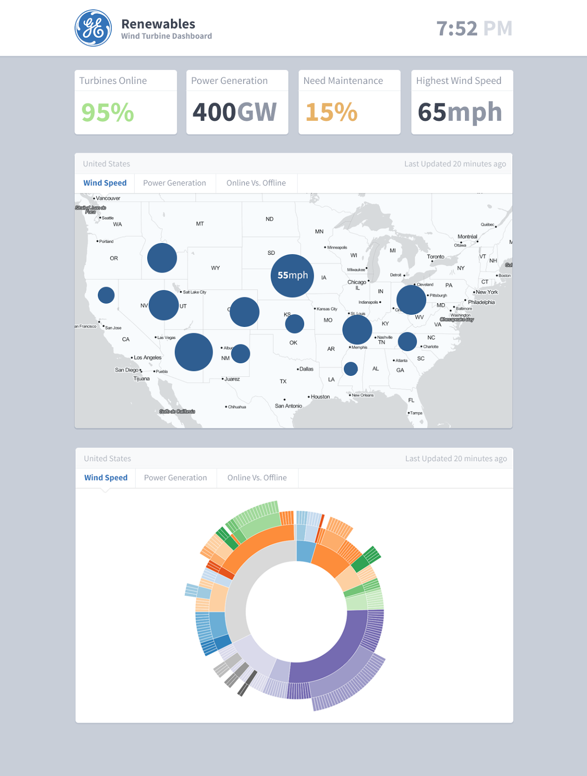

Now on clicking on the circle in the map of the interactive component screen, the user will be able to drill down to that specific region and analyse the other components which made up the bigger circle. For instance, clicking on the 55 mph circle region in the first screen will allow the user to drill down into the state and view the wind speeds of the sites in that region. The alternate view comprising of the chart will be available in this screen as well. The static header component and the menu items will be available as it is in the previous screen.

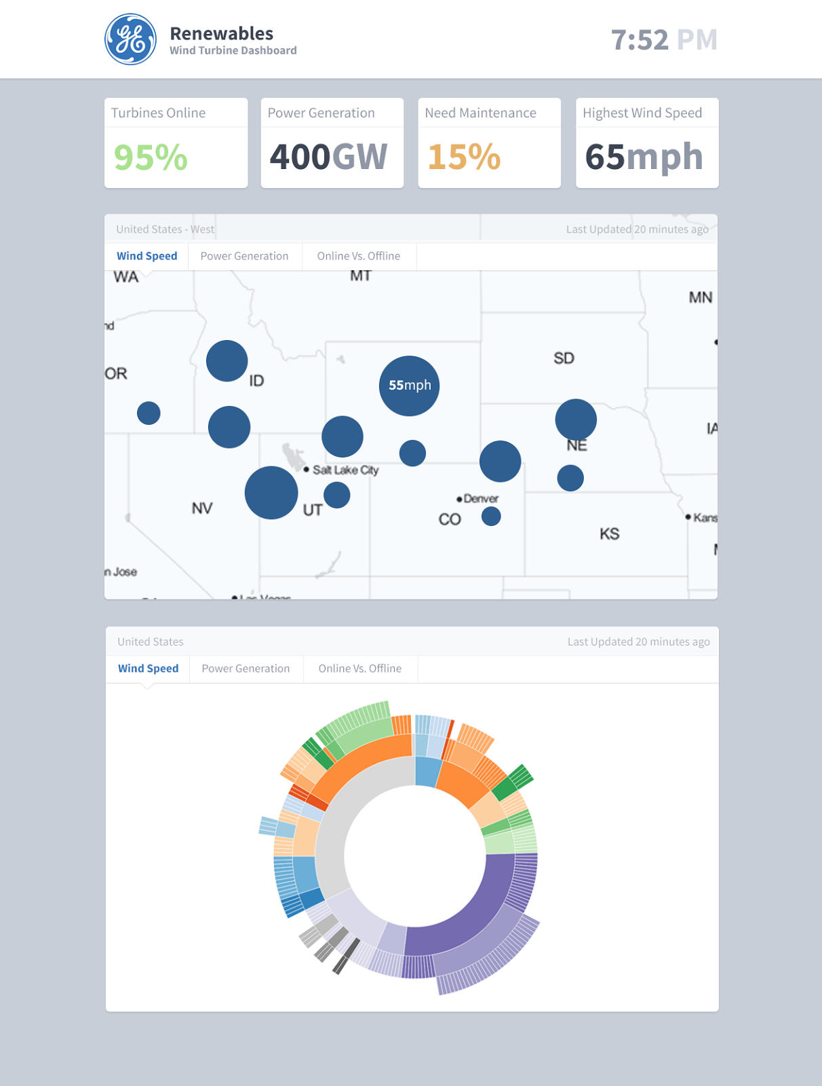

This is the pattern to be used across all menu items and for all the statistics making it a simple and clean interface.

Meeting Usability Requirements

The prototype meets the heuristics defined earlier in the document in the following manner:

- Simplicity - As mentioned, the prototype will be used by two different user groups and it should be simple enough to be understood by all. It has a very specific function of displaying data in a simple and uniform manner across all screens. This is achieved by using the simple format of map and data overlay. The important facts are laid out on the top which will catch anyone’s eye easily and effectively. This will be useful to both the casual onlooker as well as the service personnel.

- Aesthetics and minimal design - The Dashboard follows GE’s brand image by using the white and blue colour combinations. It has its own character in the sense of the functionality it performs. It uses modern charts and provides data in a clear and uncluttered format of circles in varying sizes. The whole screen is very simple with just the key components visible to the user. A clear demarcation of the static component and the interactive component is made. On clicking a region the drill down is made but follows the same styling and charting notion so as to not to confuse the user.

- Flexibility - Since the dashboard will be serving various purposes to various users the prototype needs to satisfy all those needs. If placed in a lobby the map and the data in the circles will be very appealing to the casual user, while for the service managers the other statistics and the drill down charts will be of use. The prototype also shows the various menu items which will be used by the managers to view various statistics in a similar manner. The header component will be of use to all kinds of users.

- Transparency - The prototype indicates that the dashboard will be very clear and transparent in terms of its functionalities. The menu items will be simple with the name of the statistic to be visualized. The clickable items are the maps and the circles which will allow for a drill down as is the case in most modern applications thereby following the conventions. The “Last Updated” feature allows users to see how recent the data is and understand it accordingly. The user is never confused about what data they are looking at as the other menu items are greyed out and only the selected data is highlighted in blue. This reduces the cognitive burden on the user and uses the principle of recognition rather than recall.

Thus the simple prototype captures the main heuristics which defines the specific needs of the user groups of this application.

